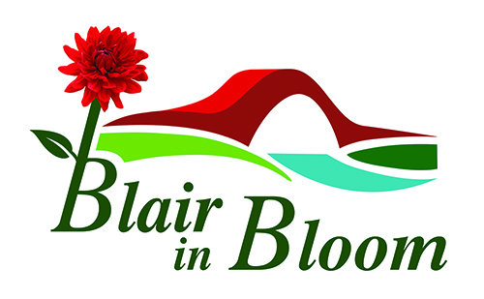
Blairgowrie & Rattray in Bloom
Volunteering Policy
(in line with the Beautiful Perth policy on volunteering)
A working definition of volunteering is “The commitment of time and energy for the benefit of society and the community, the environment or individuals outside one’s immediate family. It is undertaken freely and by choice, without concern for financial gain.” (Scottish Office circular 15/1995)
The policy acknowledges the need for “Blair in Bloom” to have a statement on volunteering. It also acknowledges the variety and crucial importance of the contribution of volunteers.
The policy:
- acknowledges the mutual benefits and value of volunteering to Blair in Bloom and the volunteer
- is a statement of commitment and support by Blair in Bloom to volunteering and volunteers
- acknowledges the current areas of volunteer involvement
- provides the Blair in Bloom committee with good practice guidance
- recognises the respective roles, rights and responsibilities of volunteers and the Blair in Bloom committee (See Appendix A attached)
Why Support Volunteering
- It gives the volunteer the opportunity to interact with the public and help make their environment look good
- Allows the volunteer to accept responsibility
- Builds relationships with colleagues
- Offers the chance to put previously learned training into practice
Volunteers make a valuable and valued contribution to the work of Blair in Bloom, in return for respect and commitment.
Volunteers will be covered by the Blair in Bloom insurance policy, both as individuals and in the context of third party coverage. This insurance does not include personal liability in respect of a criminal charge.
The overall responsibility for the implementation of this policy and related procedures rests with the Blair in Bloom committee and with the volunteers themselves.
Proposed by: Patricia Lumsden, Treasurer
Seconded Janine Seymour, Vice Chair
Date 4 June 2020

Volunteering Policy – Appendix A

Roles, Rights & Responsibilities
Blair in Bloom recognises its responsibilities with regard to the rights of volunteers and should:
- Health & Safety – provide a safe working environment for everyone
- Team work – work together to achieve aims. All team members have an equal voice
- Tasks – give clear instruction, provide a varied volunteering experience and provide appropriate training
- Commitment – only be expected to devote as much or as little time as they wish and be able to withdraw from voluntary work
- Respect confidentiality and be free from discrimination
- Communication – keep volunteers regularly informed of the current and future projects of the group
Volunteers should:
- Be reliable, honest and respect confidentiality
- Agree to disclosure checks if required
- Health & Safety – abide by Health & Safety guidance and act with care for their own safety and that of others
- Adhere to Blair in Bloom policies and procedures
- Treat colleagues with respect
- Team work – work as part of a team to enhance the town
- Tasks – undertake tasks as required

Due to current Covid-19 restrictions, this policy was approved by the
committee of
Blairgowrie & Rattray in Bloom via email correspondence.

